Modelling evolutionary rescue of populations under inbreed depression

Report of THEE research practical
Iona Nufer and Pascal Graber
07.11.2025

Inhaltsverzeichnis
Modelling evolutionary rescue of populations under inbreed depression 1
Abstract 3
Introduction 4
Methods 5
Result 6
Conclusion 9
Acknowledgements 9
References 10
Table of figures 10
Declaration of Authenticity 10
Appendix 11

Abstract
Populations experiencing inbreeding depression may face extinction when deleterious recessive alleles become fixed or nearly fixed (Robinson et al. 2019). Evolutionary rescue through genetic introgression (introducing individuals carrying alternative alleles) can restore population viability (Aguilar-Gómez et al. 2025). In our research project, we investigate the effectiveness of such interventions depending on both the number of introduced individuals and the timing of their introduction. Here, we develop a simple diploid, nonoverlapping-generation model to simulate an inbred population composed mainly of a deleterious homozygous genotype (aa), with reduced fitness relative to the heterozygous genotype (aA) and the healthy homozygous genotype (AA). Using stochastic genotype-based reproduction (following a Poisson distribution) and Hardy–Weinberg genotype formation, we evaluated how the introduction of AA individuals affects population recovery. We show that beyond a relatively small threshold (≈8–10 introduced individuals), increasing the number of introduced individuals does not substantially increase rescue probability. However, the timing of introduction strongly influences rescue success even beyond this threshold: early introductions enable high rescue probability, while late introductions mostly result in rapid extinction. Our findings highlight that both factors, number of introduced individuals and timing, matters. Early intervention with optimal number of introduced individuals is key to preventing genetic collapse in small, inbred populations.

Introduction

Evolutionary rescue was and still is an important concept in modern ecology and conservation biology. It describes populations that are declining toward extinction due to numerous factors for example genetic deterioration and can recover through the introduction of new genetic variation. Recently this topic has become more important as many populations face shrinking habitats or increased isolation. With declining population sizes, inbreeding becomes more common. Thus, there is a rise in the risk of inbreeding depression, a reduction in fitness caused by accumulation of deleterious recessive alleles over generations.

A classic example is the Florida Panther (Puma concolor coryi). This population is geographically isolated from other cougar populations, which led to severe inbreeding. As a results, more of that population began exhibiting physical and reproductive abnormalities, like a kinked tail and reduced sperm quality. Shortly before becoming extinct conservationist introduced a small number of females from a genetically diverse Texas cougar population. This successfully increased heterozygosity and reduced the frequency of deleterious alleles which restored population growth. The Florida Panther is therefore considered a textbook example of inbreeding depression and evolutionary rescue.

Another well-documented case is the Isle Royale wolf population. They became isolated on an island, resulting in a steady decline in genetic diversity over decades. In the 90s a single male wolf naturally migrated to the island across an ice bridge, which temporarily boosted genetic diversity. This demonstrated the immediate benefits of even a small genetic rescue. However, because no further migration occurred, inbreeding reduced the diversity and therefore the fitness of the population again over the last 20 years. To save the Isle Royale wolve, conservationists recently reintroduced 12 adult wolves from the mainland. Since, the population has started to recover, and the number of wolves is increasing. This shows how repeated or sustained introductions may be necessary for long- term success.

These real-world examples motivated us, to investigate the dynamics beneath evolutionary rescue events and the factors that determine their success.
Thus, our question was: How many individuals must be introduced at time x to rescue an allele of a homozygote population with low fitness?
To explore this question, we used R Studio to simulate population dynamics. The initial population in our model was homozygous for a deleterious recessive allele, leading to reduced fitness and therefore population decline. We then introduced some individuals that were homozygous for the healthy allele and tracked the resulting genotype frequencies over time. By varying parameters like introduction time, fitness levels and number of individuals introduced, we could analyse the conditions under which evolutionary rescue occurs.
Through this modelling approach, we were able to gain insight into how timing and strength of intervention interact to determine whether a declining population can recover. Our results highlight the importance of early intervention and enough input to make a genetic rescue possible.

Methods
“De part methods isch de nume ä CHATGPT skizze so us guidline “

Model Structure
We modeled a diploid population composed of three genotypes: aa, aA, and AA. Individuals reproduced in nonoverlapping-generations, with reproduction modeled via Poisson-distributed offspring numbers. Genotype fitness was represented as multiplicative scaling of expected offspring number:
- aa individuals reproduce with rate (1 − rₐₐ), representing reduced fitness due to inbreeding depression.
- aA and AA individuals reproduce with rates sₐ_{A} and s_{AA}, representing hybrid vigor and healthy genotype fitness, respectively.
After reproduction, alleles were pooled, and genotype frequencies in the next generation were assigned according to Hardy–Weinberg proportions, representing random mating and complete mixing.
Evolutionary Rescue Procedure
The initial population consisted entirely of aa individuals. At the chosen introduction point (represented mathematically by reducing N_aa as a proxy for time), a specified number of AA individuals were added to the population. We simulated 100–1000 independent replicate populations per parameter set.
We evaluated:
- Rescue probability: proportion of replicates in which the final population size exceeded the initial population size.
- Allele frequency outcomes: final frequency of allele a among rescued populations.
- Effects of introduction timing: modeled using reduced initial N_aa to represent later phases of decline.
Simulations were performed in R using the functions simulate_gen and simulate_pop, which iteratively applied genotype-based reproduction and Hardy–Weinberg reconstitution until either extinction or rescue occurred.

Result
Number of introduced individuals
Figure 1 shows that the rescue probability is increasing sharply with increasing number of introduced AA individuals, but only up to a certain threshold. Over 100 simulations, introducing 8–10 individuals was sufficient to consistently achieve ≥80% rescue probability. Beyond this point, introducing additional individuals does not substantially increase the rescue probability any further. This outcome only answers our question partially (i.e. optimal number of introduced individuals), but since we are interested in i) rescuing the originally gene pool of our starting population (a rescue in this model also includes the possible outcome of a population being rescued but only containing AA individuals, i.e. allele a is lost; see Appendix Figure 6) and ii) the time when we have to introduce the healthy homozygous individuals (AA). To be able to answer our question and include the mentioned points i) and ii), we further investigate in the frequency of allele a.
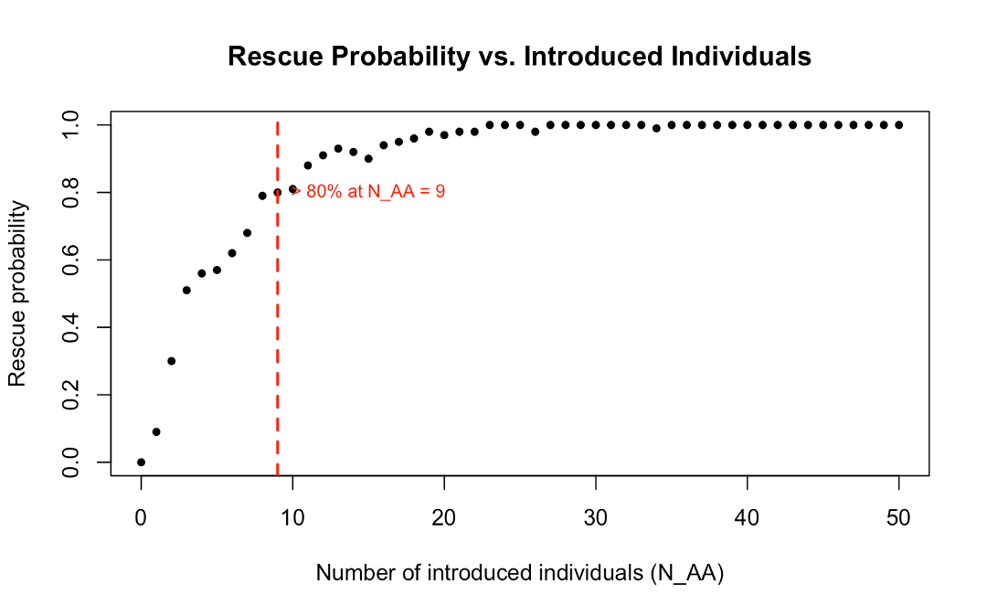
Figure 1 Rescue Probability vs. Number of Introduced Individuals
This figure shows the rescue probability of the population (on the y-axes) as a function of the number of introduced healthy homozygous individuals (N_AA) (on the x-axes). Each point represents the proportion of successful rescues across 100 replicates, where a rescue is defined as the final population size is reaching or surpassing the initial population size at the end of a simulation. The rescue probability increases sharply within the first ten introduced individuals, reaching approximately 80% success rate at N_AA ≈ 9. This value is indicated by the dashed red line. Beyond this threshold, additional introductions leading to a rescue probability that approaches saturation near 100%.

Frequency of allele a
Figure 2 seems to illustrate that the allele frequency gets higher with increasing number of introduced individuals. But this positive correlation vanishes if we remove the extinction events from our plot, as it is shown in Figure 3. The reason why we exclude the extinction events is to observe if there is an effect on the allele frequency when we increase the number of introduced individuals further than the optimal threshold (Figure 1) (i.e. we are not interested in a number of introduced individuals below 8). Since after this threshold the rescue probability is ≥80% and rapidly increasing to 100%, we can exclude extinction events and use this approach to show that there is no “significant” (or no strong positive) effect on the allele frequency by increasing the number of introduced individuals any further than the threshold.
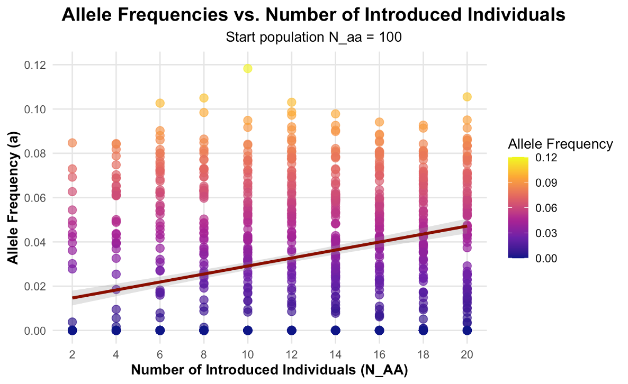
Figure 2 Allele Frequencies vs. Number of Introduced Individuals with Extinction Events
This figure shows the frequency of allele a of the total population (y-axes) as a function of the number of introduced healthy homozygous individuals (N_AA) (x-axes). The initial population (N_aa) is fixed at 100 individuals. Each point represents the proportion of the allele frequency after one simulation and for each number of introduced individuals (2-20) 100 replicates are performed. Allele frequency magnitude is indicated with different color intensity. Rescue is defined the same way as stated in the caption of Figure 1. The fitted regression trend (red line) shows a positive correlation between increasing number of introduced individuals and the allele frequency. It is important to notice that this illustration is including all the extinction events (i.e. where rescue has failed) which affect the regression line.
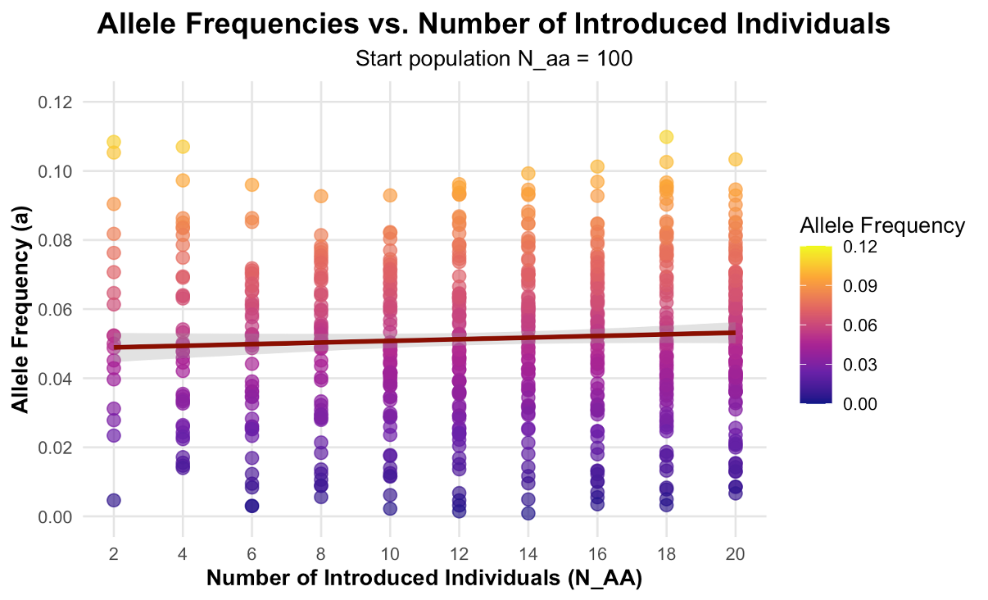
Figure 3 Allele Frequencies vs. Number of Introduced Individuals without Extinction Events
This figure again shows the frequency of allele a of the total population (y-axes) as a function of the number of introduced healthy homozygous individuals (N_AA) (x-axes). The initial population (N_aa) is fixed at 100 individuals. Each point represents the proportion of the allele frequency after one simulation and for each number of introduced individuals (2-20) 100 replicates are performed. Allele frequency magnitude is indicated with different color intensity. Rescue is defined the same way as stated in the caption of Figure 1. The fitted regression trend (red line) now doesn’t show the same positive correlation as seen in Figure 2, instead it is nearly horizontal. Here it is important to notice that this illustration is excluding all the extinction events (i.e. where rescue has failed) which affect the regression line.
Timing of Introduction
In Figure 4 we can observe the effect of the time, i.e. when we introduce our healthy homozygous population (N_AA), on the frequency of allele a. The timing of the intervention had an effect on the allele frequency as well as for the rescue probability. Early introductions, while the initial population remained relatively large, resulted in higher allele frequencies and in high rescue probability. This effect is even stronger visualized in Figure 8 (see Appendix), when intervention was carried out with small introduction numbers. In contrast late intervention often resulted in failed rescue and smaller allele frequencies.

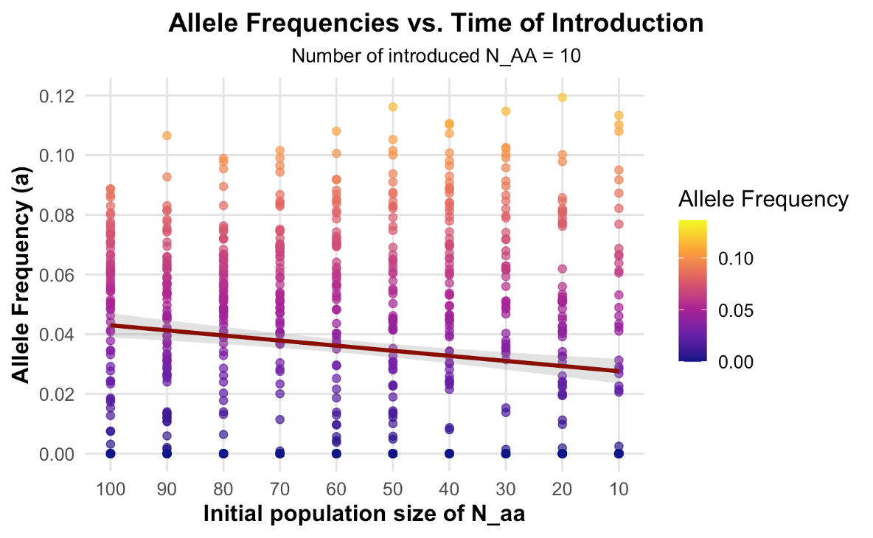
Figure 4 Allele Frequencies vs. Time of Introduction
This figure shows the frequency of allele a of the total population (y-axes) as a function of the initial population size of the deleterious homozygous genotype (N_aa) (x-axes). The number of introduced individuals (N_AA) is fixed at 10 individuals. The initial population size is used as a proxy for time, i.e. the smaller the initial population size the further time has passed (since the initial population is declining over time). Each point represents the proportion of the allele frequency after one simulation and for each initial population size (100-10) 100 replicates are performed. Rescue is defined the same way as stated in the caption of Figure 1. The fitted regression trend (red line) shows a negative correlation between allele frequency over time, i.e. the allele frequencies are declining over time. It is also important to notice that with ongoing time more extinction events occur, indicated with fewer points occurring in the plot the more time has passed.

Conclusion
Our model demonstrates that successful evolutionary rescue in inbred depressed populations depends on both factors, the absolute number of introduced individuals of a homozygous healthy population and the timing of the intervention. But timing seems to play a superior role after knowing the crucial number (rescue ≥80%) of introduced individuals. Introducing 8-10 Individuals lead to a rescue probability of over 80 percent and by introducing this fixed number of individuals the only way to improve the allele frequency of a is to act early on, i.e. early introductions are far more effective than late ones. The findings therefore do answer our research question: How many individuals (8-10) must be introduced at time x (Early interventions) to rescue an allele of a homozygote population with low fitness? Our model therefore provides a simple but informative framework to guide management of genetically compromised populations in deciding how many and when to introduce individuals to prevent extinction.

These results also align with documented conservation cases such as the Florida panther (Aguilar-Gómez et al. 2025) and Isle Royale wolves (Robinson et al. 2019), where delayed interventions limited the scope of successful recovery of these populations.
Despite these positive findings our model comes along with some limitations. Can we consider a population is rescued if the genetic component of the original population gets lost? For this reason, we focused on the allele frequency of the initial population (allele a). The results show that allele a does not disappear entirely, instead it stabilizes at moderate frequencies around 3-10% of the total gene pool. This relatively low abundance of the allele a is explained by the strong deleterious effect of being homozygous for this allele (r_aa = 0.2). If we weaken the effect of this deleterious allele the frequency is increasing strongly. On the other hand, these low frequencies are also consistent with the outcomes in the Florida panther, where ancestral genotypes persisted post-introgression. Some other limitations are clearly, that this is a very simplified model, there are no overlapping generations (parents die after reproduction), different life stages (every individual can immediately reproduce), environmental factors (e.g. habitat degradation or climate change), density dependence (negative nor positive, no carrying capacity) etc., included in this model. These factors that could be implemented in our model to make it more realistic and projectable to nature. In further research we would clearly investigate how a carrying capacity and adjusting some parameter settings (e.g. effect of overdominance in hybrids) would influence our model and the outcomes of it.

Acknowledgements
At this point we like to thank our supervisor Claudia Bank and all the assistants namely, Franziska Andrea Brenninger, Russell Jackman Jasper, Ana-Hermina Ghenu, and Julio Antonio Ayala Lopez for all the support they provided to use during this research practical. The provided base R-code and the short lecture inputs they presented helped us to improve our skills with tools like R-Studio, GitHub and to optimize our general workflow in scientific research. They always had an open ear for all our problems and were very patient when some frustration occurred. So, for all these mentioned reasons and many more: Thank you all!

References
Aguilar-Gómez, Diana, Lin Yuan, Yulin Zhang, et al. 2025. “Genetic Rescue of Florida Panthers Reduced Homozygosity but Did Not Swamp Ancestral Genotypes.” Proceedings of the National Academy of Sciences 122 (31): e2410945122. https://doi.org/10.1073/pnas.2410945122.
Robinson, Jacqueline A., Jannikke Räikkönen, Leah M. Vucetich, et al. 2019. “Genomic Signatures of Extensive Inbreeding in Isle Royale Wolves, a Population on the Threshold of Extinction.” Science Advances 5 (5): eaau0757. https://doi.org/10.1126/sciadv.aau0757.

Table of figures
Figure 1 Rescue Probability vs. Number of Introduced Individuals 6
Figure 2 Allele Freq. vs. Number of Introduced Individuals with Extinction Events 7
Figure 3 Allele Freq. vs. Number of Introduced Individuals without Extinction Events 7
Figure 4 Allele Frequencies vs. Time of Introduction 8
Figure 5 Lifecycle of our model 11
Figure 6 Possible outcomes of one population simulation 11
Figure 7 Multiple populations with changing parameters 12
Figure 8 Allele Frequencies vs. Time of Introduction (varying N_AA) 12

Declaration of Authenticity
We hereby declare that we have written this report independently and that all sources used have been appropriately cited. Artificial intelligence tools (ChatGTP by OpenAI) and DeepL were used to refine the language and improve readability.

Appendix

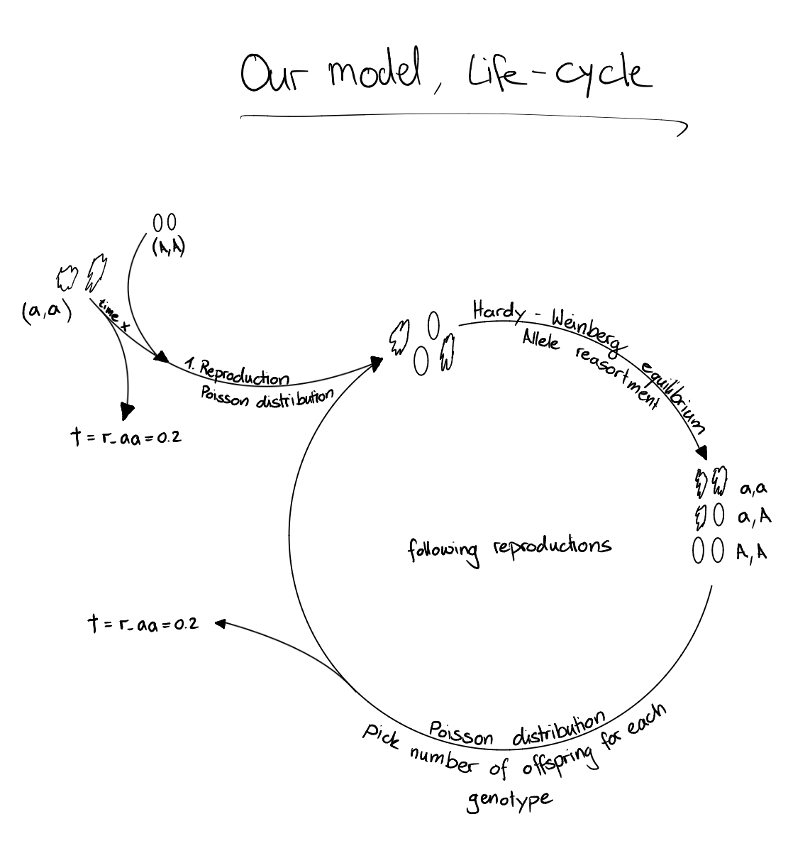
Figure 5 Lifecycle of our model

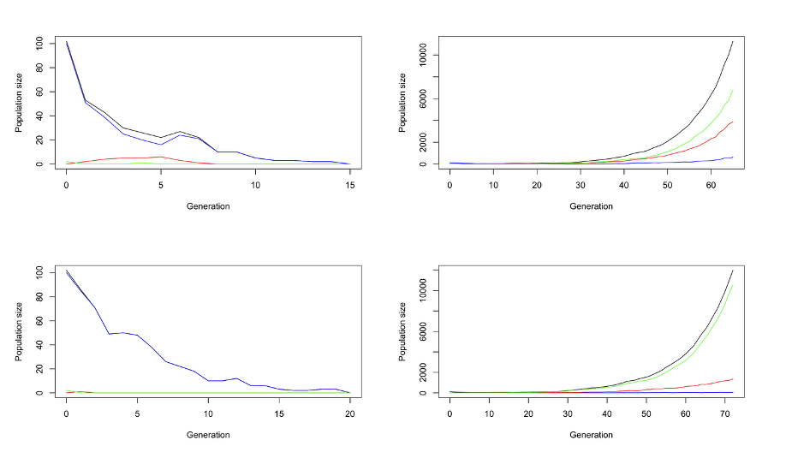
Figure 6 Possible outcomes of one population simulation

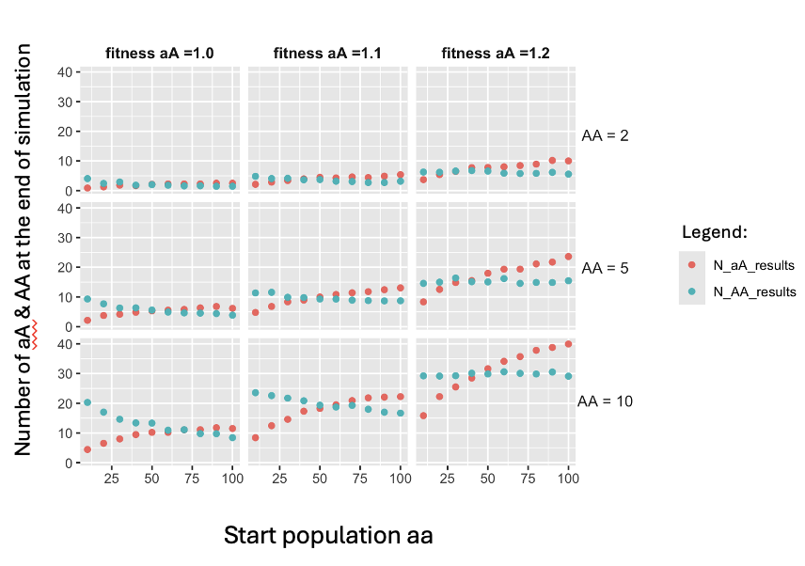
Figure 7 Multiple populations with changing parameters

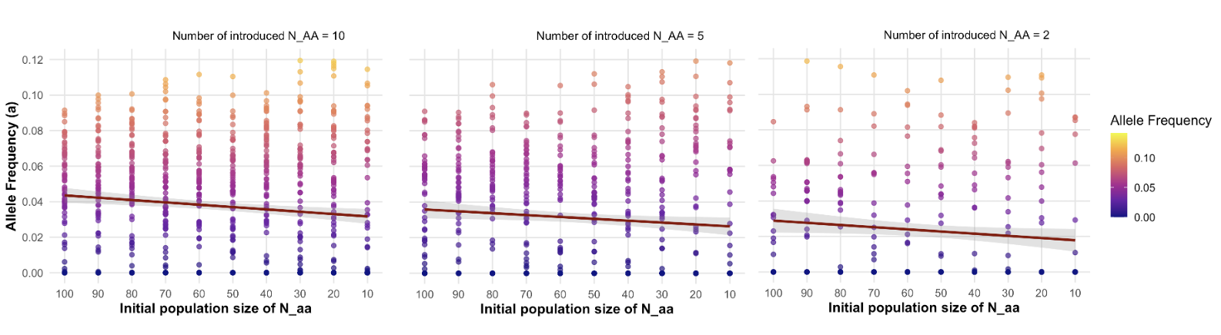
Figure 8 Allele Frequencies vs. Time of Introduction (varying N_AA)
This figure shows the frequency of allele a of the total population (y-axes) as a function of the initial population size of the deleterious homozygous genotype (N_aa) (x-axes). The number of introduced individuals (N_AA) varies from 10, 5, and 2 individuals. The initial population size is used as a proxy for time, i.e. the smaller the initial population size the further time has passed (since the initial population is declining over time). Each point represents the proportion of the allele frequency after one simulation and for each initial population size (100-10) 100 replicates are performed. Rescue is defined the same way as stated in the caption of Figure 1. The fitted regression trend (red line) shows a negative correlation between allele frequency over time, i.e. the allele frequencies are declining over time. It is also important to notice that with ongoing time more extinction events occur, indicated with fewer points occurring in the plot the more time has passed.

